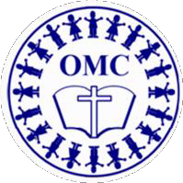
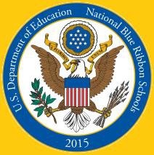
2015 National Blue Ribbon School of Excellence
Our Mother of Consolation Parish School

17 E. Chestnut Hill Avenue ♦ Philadelphia, PA 19118
school.omcparish.com ♦ www.facebook.com/OMCParishSchool

2020-21 Tuition Rates

Tuition for First Grade through Eighth Grade

 | OMC Participating Parishioner | Catholic  Non-Parishioner | Non-Catholic
# of  Children | Tuition | Tuition | Tuition
1 | $ 5,305  030 | $ 6,125 | $ 6,425
2 | $ 10.210 | $12,050 | $12,850
3 | $14,615 | $17,675 | $19,375
4 | $19,020 | $23,300 | $25,700

Tuition for Pre-K and Kindergarten

Program | Schedule | Full Tuition – Before Applicable Discounts
 |  | PK3 | PK4 | K
5 Days | Monday through Friday  8:15 – 2:40 | $7,975 | $7,375 | $6,550
3 Days | Monday, Wednesday, Friday 8:15 – 2:40 | $6,575 | $5,975 | Not offered

Discounts Available to Pre-K/Kindergarten Students

 | Parishioner | Catholic  Non-Parishioner
Multi-Child Discount
Second Child Enrolled | $400 | $200
Each Additional Child Enrolled | $900 | $500
Kindergarten Loyalty Discount (provided for all students who enter Kindergarten from OMC Pre-K)
Students who completed PK4 at OMC | $500
Students who completed PK3 and PK4 at OMC | $1,000

Withdrawals after Sep. 1 incur a $500 fee per student and scholarships will be forfeited.

Kindergarten students receive the larger of the Loyalty Discount or the Multi-Child Discount.

