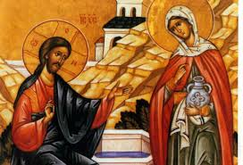
In John Chapter 4 Jesus encounters the woman at the well. He crosses social borders to talk to her and to offer her water that will quench her thirst. Named after this story The Well was started by The Welcome Church here in Philly. It is one of the only all women shelters in the city. The shelter provides meals, safety, community, and assistance to all of its guests. Many of the women who stay at the well go on to find permanent housing. An OMC parishioner currently makes meals for The Well twice a month and is looking for some help. This is a great opportunity for OMC students and families to provide a meal for those in need. If you would like to make a full meal for 10 people please email Mr. Cillo. We would like to find one family for each month.

For more information about The Welcome Church check out their website here: https://www.thewelcomechurch.org/Getting-to-Know-Us.html
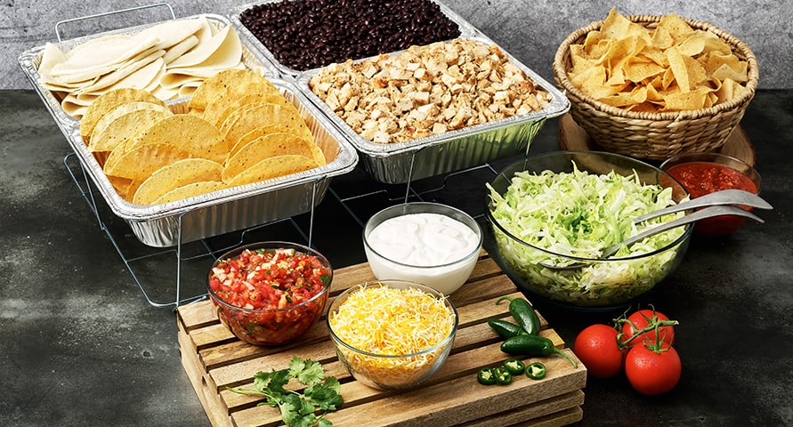
Contact Mr. Cillo at pcillo@omcschool.com to sign up or for meal ideas.

