Yummy Meatless Meals

During Lent we are called to pray, fast, and give alms. Join OMC in doing all three through Catholic Relief Services Operation Rice Bowl!

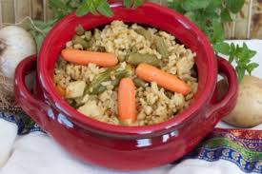

Families are encouraged to pick a meatless meal from https://www.crsricebowl.org/recipe and make a video of your family cooking the meal. Be sure to begin or end with a prayer such as the direction of intention or grace before eating. At the end of the meal remember to put the money you saved by not buying meat – an average of $3 per person per meal – into your CRS Rice Bowl to feed our brothers and sisters in need around the world.

Post your videos to youtube, share them to the facebook page or send them to Mr. Cillo to have them shared with the OMC community. All students who participate will receive a NUT pass and the videos will be watched as a school during Holy Week. Make sure to submit your video by April 13th.

Can’t make a video? Use the Lenten calendar and resources from Catholic Relief Services to celebrate Lent and learn more about our sisters and Brothers around the world.

